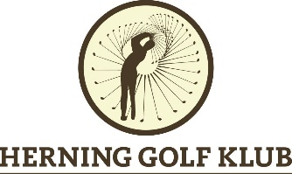

Danish Paragolf Open 2021

June 29th – 30th 2021
Herning Golf Klub – Trehøje Golfklub

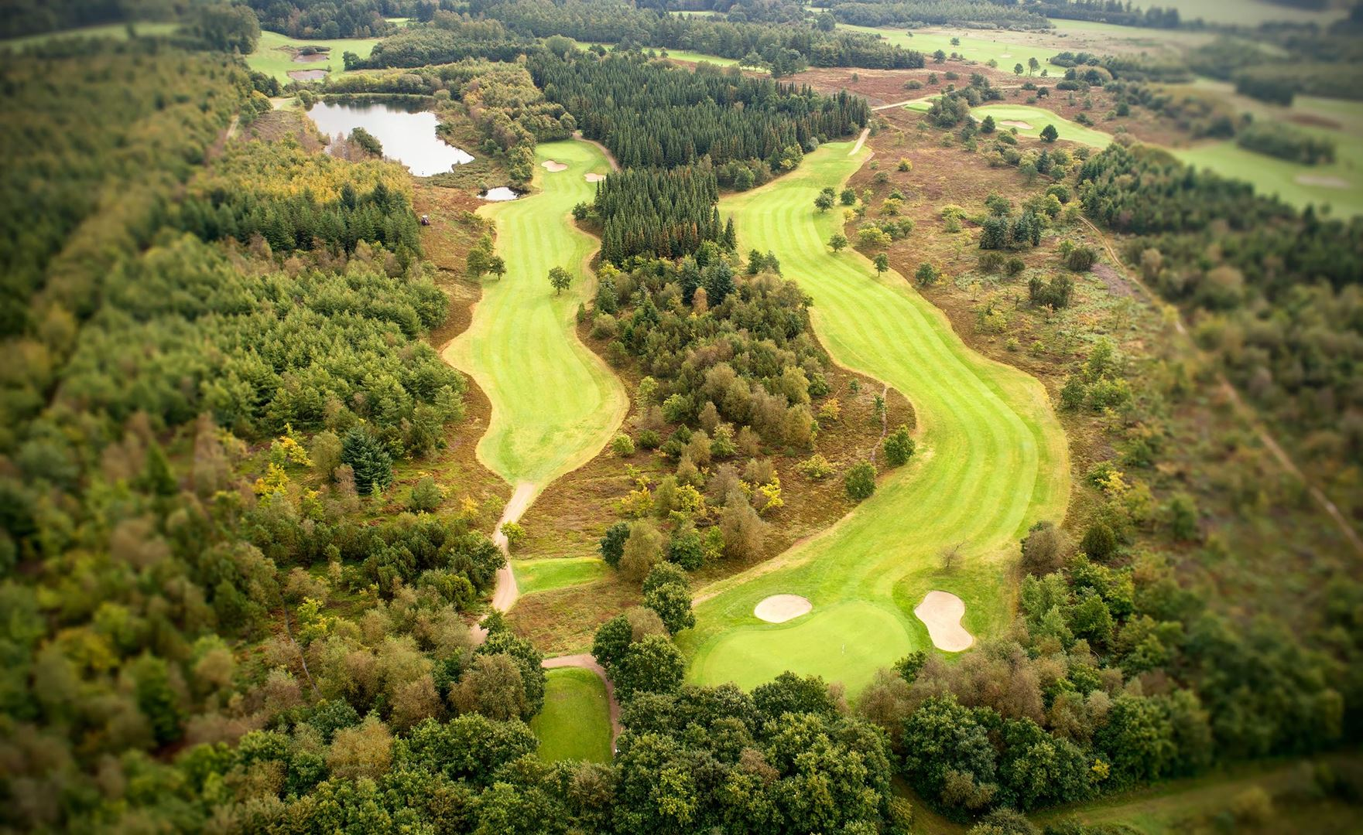

Venue:
Tuesday, June 29th: Herning Golf Klub, Golfvej 24, 7400 Herning www.herninggolfklub.dk
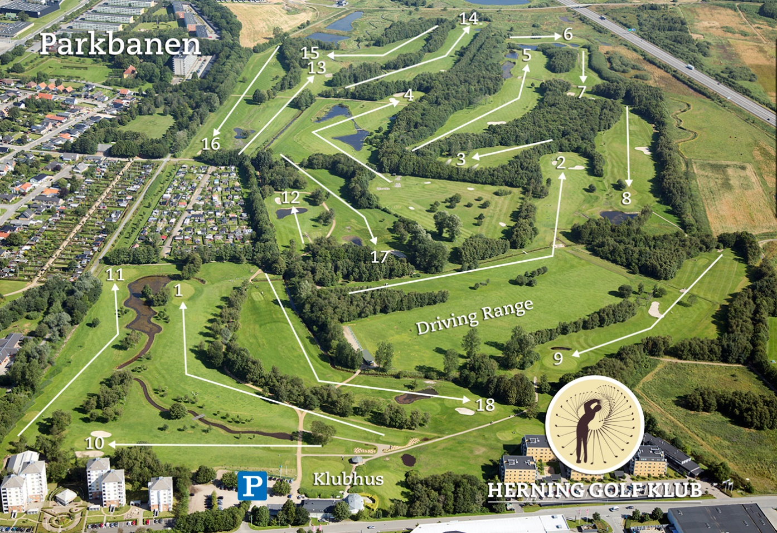
Wednesday, June 30th: Trehøje Golfklub, Røddingvej 21A, 7480 Vildbjerg
www.trehoje-golf.dk
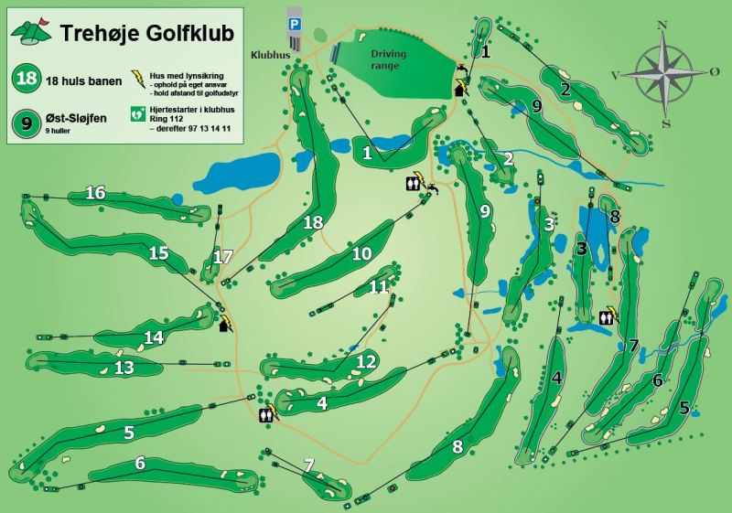

Tournament Schedule:
- Monday June 28th Prioritized Practice Round
- Tuesday June 29th First Tournament Day, Herning Golf Klub
- Wednesday June 30th Final Tournament Day, Trehøje Golfklub
Eligibility:
Players from all disability categories, with a nationally recognized golf handicap of not more than 54, who have an Access Pass or a WR4GD Pass.
Maximum 80 Players (with a maximum of 10 wheelchair players.)
Classes
Category 1: Hcp. +8 – 18,4, Strokeplay
Category 2: Hcp. 18,5 – 53,9, Stableford

Prizes:
In each category there will be the following prizes:
- First prize (1 – 8 players)
- Second prize (9 – 15)
- Third prize (> 15)
- Best female player
- Best mobility device assisted player.
Player Tournament Fee: EUR 125 / DKK 950
- Prioritized practice round Monday – or any day with edga membership
- 2 days of tournament access (Tuesday and Wednesday)
- Buggy or trolley (first come, first served principle) (Tuesday and Wednesday)
- Drivingrange balls unlimited
- Prize giving ceremony (Wednesday)
- Lunch pack including sandwich, water and fruit (Tuesday and Wednesday)
- Main meal after the golf round (Tuesday and Wednesday)
Optional purchase package for accompanying person: EUR 75 / DKK 575
- Greenfee Monday combined with prioritized practice round for player.
- Drivingrange balls unlimited
- Lunch pack including sandwich, water and fruit (Tuesday and Wednesday)
- Main meal after each tournament round (Tuesday and Wednesday)
Entry Form
Registration and payment at GolfBox:
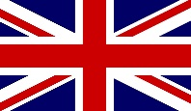
where the entry list and the full conditions can be viewed.
Closing date for entries: June 7th, 2021
Registrations will be accepted until the closing date for entries or filling of complete start field. Your participation will be confirmed by the organizer immediately. Registrations after this point will be accepted and placed on a reserve list on a and served on a first come, first served basis in case of cancellation.
Rules
The tournament is played in accordance with the 2019 Rules of Golf, the Modification of the Rules of Golf for Golfers with Disabilities as approved by R&A Rules Limited and the Local Rules as approved by the Championship Committee.
Contacts
Trehøje Golfklub, Golfmanager Maibrit Juhl, tlf. +45 3031 5489, mj@trehoje-golf.dk
Herning Golf Klub, Golfmanager Bo West Møller, tlf. +45 40 422 422, bwm@herninggolfklub.dk
EDGA Denmark, Peter Møller, tlf. +45 3027 3443, durcaspeter@gmail.com
Official Hotels:
Accommodation must be booked directly at the hotel:
Dolphin Hotel, Engdahlsvej 16, 7400 Herning, phone +45 9722 1522, www.dolphinherning.dk
EUR 100 / DKR. 749 for double room with breakfast
Distance from Herning Golf Klub, 750 mtr. – from Trehøje Golfklub, 27 km
Østergaards Hotel, Silkeborgvej 94, 7400 Herning, phone +45 9712 4555, www.oestergaardshotel.dk
EUR 100 / DKR. 750 for double room with breakfast
Distance from Herning Golf Klub, 1 km. – from Trehøje Golfklub, 27 km.
Vildbjerg Sportscenter, Sportsalle 6, 7480 Vildbjerg, phone +45 9627 0700, www.sportscenter.dk
EUR 120 / DKR. 895 double room with breakfast / EUR 80 / DKR. 595 single room with breakfast
Distance from Herning Golf Klub, 21 km. – from Trehøje Golfklub, 6 km.
Or Camping:
https://www.visitherning.dk/explore/overnatning-cid19/campingpladser-cid24
Airport:
Billund Airport, 7190 Billund
Distance from Herning Golf Klub, 56 km. – from Trehøje Golfklub, 85 km.

